Department of Computer Engineering Academic Year: 2025-26
Assignment- No. 2


Semester: IV Sem Section : A,B
Course Name: Design & Analysis of Algorithm Course Code: BTCME601T Date of Allotment:30/03/2026 Date of Submission: - 20th April 2026
 | Que. | Question |  |  |  |  |  |  |  |  | Course Outcome
 | Q1 | Explain basic principle of Dynamic programming and principle of optimality.  Also explain the difference between Dynamic Programming and Greedy algorithm. |  |  |  |  |  |  |  |  | CO-03
 | Q2 | Solve the following Longest Common Subsequence (LCS)  x = a a b a a b a b a a y = b a b a a b a b |  |  |  |  |  |  |  |  | CO-03
 | Q3 | 1. Find Optimal Binary Search Tree (OBST) |  |  |  |  |  |  |  |  | CO-03
 |  |  | i | 0 | 1 | 2 | 3 | 4 | 5
 |  |  | Pi | - | 0.15 | 0.10 | 0.05 | 0.05 | 0.15
 |  |  | qi | 0.05 | 0.08 | 0.12 | 0.05 | 0.15 | 0.05
 | Q4 | 1. Solve by Matrix Chain Multiplication  A = 8 x 12, B = 12 x 14, C = 14 x 6, D = 6 x 15 |  |  |  |  |  |  |  |  | CO-03
 | Q5 | Implement Travelling Salesman Problem for the graph represented by following matrix  0 8 16 15  14 0 9 12  7 10 0 6  11 13 10 0 |  |  |  |  |  |  |  |  | CO-03
 | Q6 | For the following multistage graph, obtain a recurrence relation for finding the shortest path from source vertex to destination vertex. Also explain the calculation for shortest path. |  |  |  |  |  |  |  |  | CO-03

A 4 D
1 18
11 9

S 2 B 5 E 13 T

16 2

5
C 2 F

Name & sign of Subject Teacher




Department of Computer Engineering Academic Year: 2025-26
Assignment – No. 3(CO-single Activity)
Semester: IV Sem Section: A,B
Course Name: Design & Analysis of Algorithm (NEP-2020) CBCS Course Code:BTCME601T Date of Allotment:30/03/2026 Date of Submission: - 20th April 2026

Q1 | Write short note on Approximation algorithm. | CO-04
Q2 | 1. Elaborate the Min-Cut process. Write the min-cut algorithm, consider the example and solve it by min cut method.  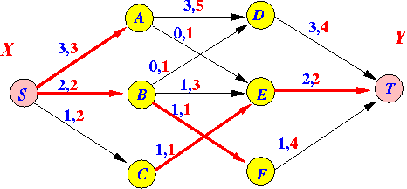 | CO-04
Q3 | Define amortized analysis. State and explain the three main techniques for amortized analysis. | CO-04
Q4 | Discuss about the LasVegas and Monte-Carlo in details with example. | CO-04
Q5 | Explain P, NP, NP-hard and NP-complete with neat diagram. | CO-05
Q6 | Write algorithm to find Hamiltonian cycle for given graph. For the given graph generate at least two cycle.  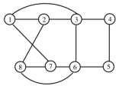 | CO-05

Name & sign of Subject Teacher

